Activity 4: Graphical User Interface   
Jan Benedict J Ante BSIT 3-C   
Feb 21, 2024

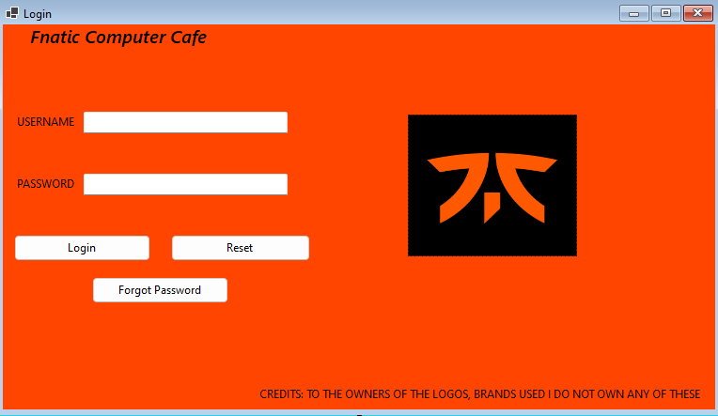

LOGIN WINDOW /FORM

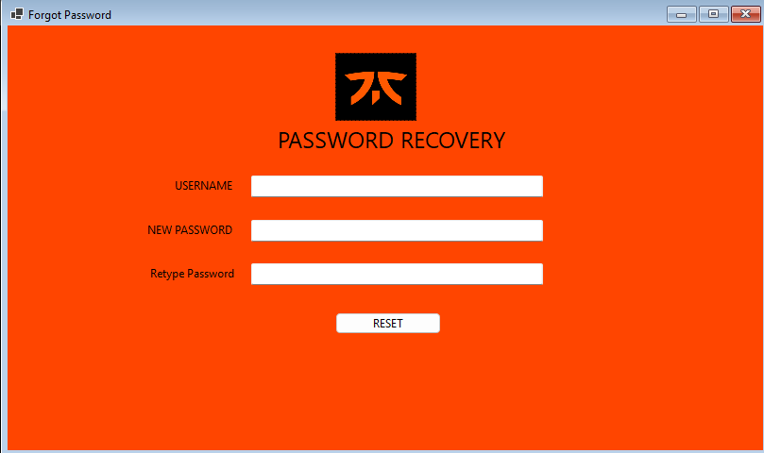

FORGOT PASSWORD FORM

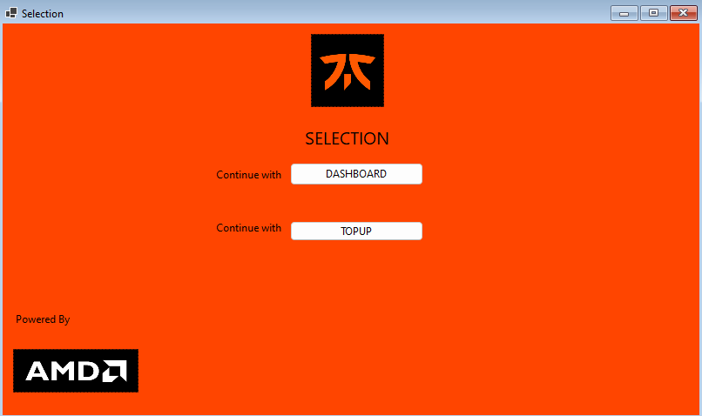

SELECTION FORM

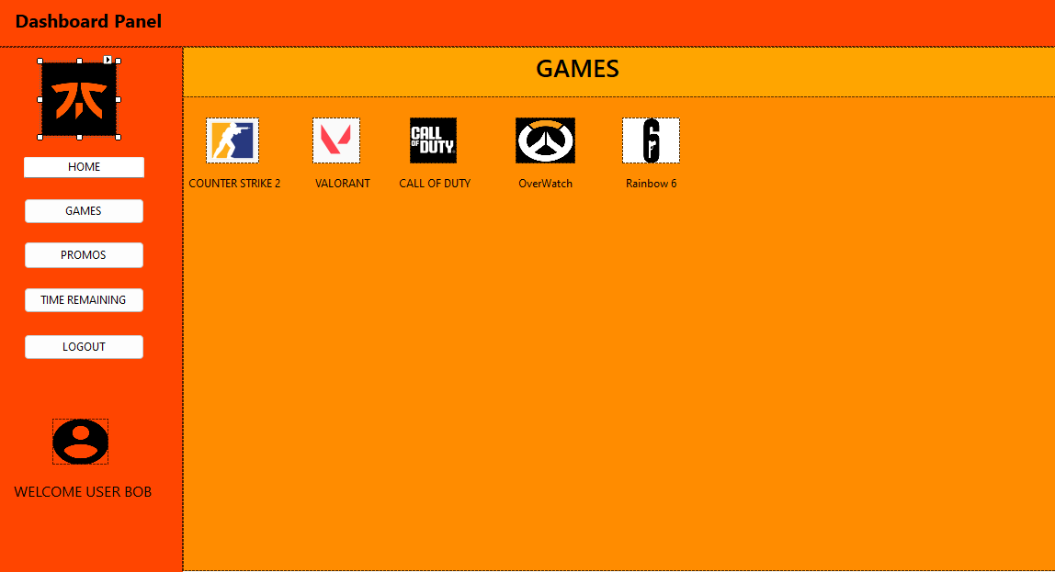

DASHBOARD FORM

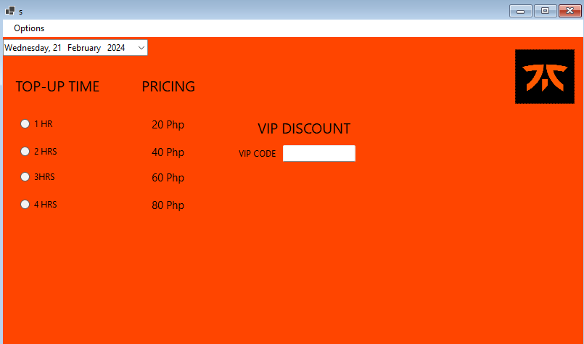

TOPUP FORM